Understanding Audience –

A Machine Learning Approach to Customer Segmentation

**Team Number:**

**Submitted To: SmartInternz Team**

**Batch: VIT – AP AI/ML Morning Batch**

**Year: 2023**

**DONE BY:**

**Vaishnavi T Sundari Dhulipala – 21BCE9174**

**Vintha Kuyili Ramyasri – 21BCE9204**

**Lakshmi Srujana Vankayala – 21BCE9181**

**Deepthimahanty Harshita – 21BCE9230**

PHASE - II

PROJECT DESIGN PHASE:

Determine the Requirements:

|  |  |
| --- | --- |
| Date | 7 November 2023 |
| Team ID | Team-591849 |
| Project Name | Project – Understanding Audiences |
| Maximum Marks | 4 Marks |

**Data Flow Diagram:**

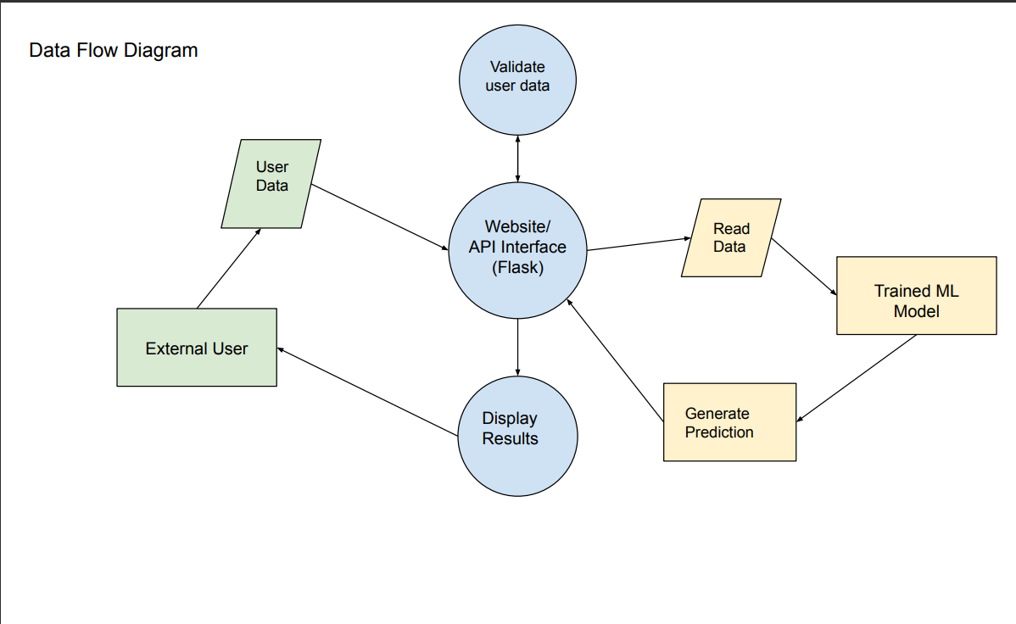

|  |  |  |  |  |  |  |
| --- | --- | --- | --- | --- | --- | --- |
| **User Type** | **Functional**  **Requirement (Epic)** | **User Story**  **Number** | **User Story / Task** | **Acceptance criteria** | **Priority** | **Release** |
| Client (Website) | Prediction of the  Potential Customer | USN-1 | As a client, I can know the no of highly potential customers in my company | I can receive the highly potential customers | Medium | Sprint-1 |
| Client (Website) | Prediction of the  Potential Customer | USN-2 | As a client, I can know the no of highly potential and low potential customers in my company | I can receive highly potential and low potential customers | High | Sprint-1 |
| Client (Website) | Prediction of the  Potential Customer | USN-3 | As a client, I can know the no of highly potential, low potential and average customers in my company | I can receive highly potential, low potential and average customers | High | Sprint-1 |
| Client (Website) | Prediction of the  Potential Customer | USN-4 | As a client, I can know the potential customers in my company | I can receive potential and average customers | Low | Sprint-2 |

**User Stories**